Joint Optimal Service Chain Allocation, VNF instantiation and Metro Network Resource Management

Author name(s) [10-point type, centered, bolded]
¹Universidad Politécnica de Cartagena, Cuartel de Antiguones, Plaza del Hospital 1, 30202 Cartagena, Spain
Email: javier.moreno@upct.es

Abstract: Within the Metro-Haul project, we demonstrate the interaction of ETSI Open-Source Mano (OSM) Network Function Virtualization-Orchestrator (NFV-O) and open-source Net2Plan planning tool to jointly optimize VNFs placement and the metropolitan optical transport network resources.
OCIS codes: (060.4250) Networks; (060.4256) Network Optimization.

1. Introduction
Metropolitan area networks play an essential role in telecom operators’ infrastructure to satisfy the near-future requirements of the 5G era. Among other key performance indicators, 5G networks are expected (i) to use a scalable management framework enabling fast deployment of novel applications, (ii) to reduce the network management OPEX by at least 20% compared to today and (iii) to ensure End-to-End latency below 1ms.
A partir de aqui, para concluir el parágrafo de aqui encima, yo haría tres frases, para tartar precisamente (i) introduciendo SDN y NFV como conceptos clave en “scalable management frameworks”, (ii) SDN y NFV permiten conceptos de “disaggregated” y multi-vendor interoperable networks que reducen opex, y finalmente (iii) la optimización de “Service Chain Allocation, VNF instantiation and Metro Network Resource Management” usando algoritmos, o mejor, frameworks de optimitzación (lease Net2Plan) es imperativo!

El siguiente parágrafo es literal de https://5g-ppp.eu/metro-haul/ habría que decidir si nos sirve, y dónde. Si así, separado al final o junto con el anterior.

In this context, Metro-Haul [1] proposes cost-effective, energy-efficient, agile and programmable metro networks that are scalable for 5G access and future requirements, encompassing the design of all-optical metro nodes (including full compute and storage capabilities), which interface effectively with both 5G access and multi-Tbit/s elastic core networks.
2. Overview
This demonstration showcases the interaction… lo mismo que el abstract pero expandido, con detalle.

Un parágrafo para hablar de “como es una red metr-haul” y como son los nodos metro haul. No es trivial que nodos ópticos tengan IT resources.

Un parágrafo de cada módulo relevante de la figura.

Considerar algunos algoritmos de Net2Plan que se puedan usar aquí.

Usar el contenido de las slides de Oscar:

Metro-Haul Network:
Interconnected Metro edge and Metro core nodes
Edge DC and regional DC attached to edge & core nodes

Goal:
Proof of concept of the use of a specialized planning tool using xxx algorithms to assist NFV-O and T-SDN in the optimal VNF placement and optimization of transport network
Demonstrate the interaction of well-known ETSI OSM NFV orchestration suite and open-source Net2Plan planning tool.
Demonstrate the use of standard Topology interfaces to provide detailed multi-layer topological information to the planning tool

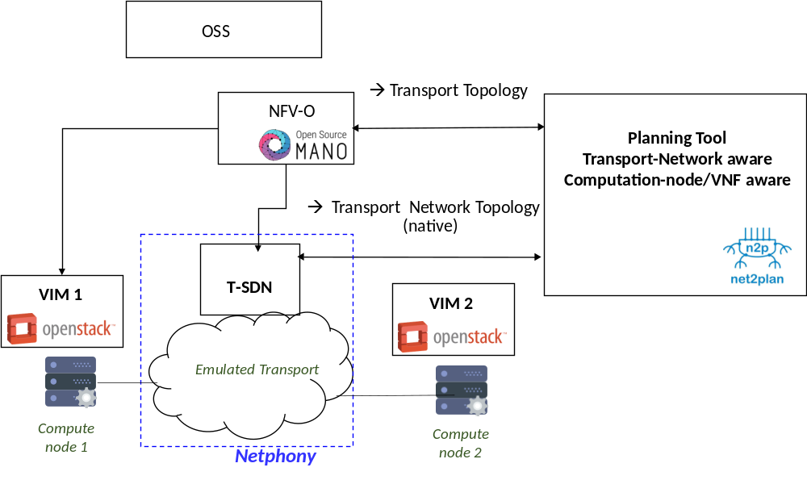
Fig. 1. Demonstration overview. NFV-O: Network Function Virtualization – Orchestrator. OSS: VIM: Virtual infrastructure manager.

3. Innovation
Texto anterior.
Es OSM reciente? Hay otra gente que ya lo haya usado y/o definido interfaces para comunicarse con OSM?
Además, explicar que respecto a las demos del año pasado (que “solo” definían interfaces) nosotros estamos un paso adelante porque usamos algoritmos de optimización (open-source available).

4. OFC Relevance

Acknowledgments
This work has been performed in the framework of the H2020-ICT? xxx Metro-HAUL project number yyy…
References
- https://metro-haul.eu/
- Open Source Mano. [Online]. Avalilable: https://osm.etsi.org/
- [3] P. Pavon-Marino et al., “Net2Plan: An Open Source Network Planning Tool for Bridging the Gap between Academia and Industry”, IEEE Networks, Sept. 2015.
- Y. Li and M. Chen, “Software-Defined Network Function Virtualization: A Survey,” in IEEE Access vol. 3 pp. 2542-2553, 2015 (no creo que esta ref sea necesaria)
- Añadir algunas de las refs de demostraciones OFC 2017.

